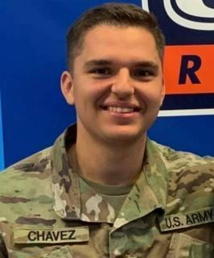 GUSTAVO (NMN) CHAVEZ
3340 Ranch Park Trl. Round Rock, TX.
(512)-949-9203 052chavez@gmail.com

EDUCATION

The University of Texas at San Antonio

Bachelor of Business Administration

Major in Cyber Security, 3.20 GPA.

LEADERSHIP EXPERIENCE

Charlie Company Commander - UTSA Army ROTC, San Antonio, TX. August 2021 - Present
- Lead and manage all aspects of administrative and personnel needs within Charlie company.
- Learned new skills rapidly and applied to daily tasks, improving efficiency and productivity of the company.
- Manage and supervise all company activities and deadlines at a fast-paced environment.
Squad Leader - UTSA Army ROTC, San Antonio, TX. March 2021 - July 2021
- Produced reports on equipment status, incidences, personnel readiness, and intelligence for superiors.
- Led fire teams during battle drills, training exercises, and PT sessions.
- Manage property and equipment inventory and crew assignments for the squad.

WORK EXPERIENCE

Sales Associate Lead - Orange Theory Fitness, San Antonio, TX. December 2019 - December 2021
- Engage and interact with customers to build rapport and lasting relationships.
- Trained and developed new hires on company processes, product knowledge, customer service and selling techniques.
- Solved customer challenges to satisfaction following company policies and regulations.

Boxing Instructor (Volunteer) - AOA Boxing Gym, Round Rock, TX May 2019 - Present
- Established clear benchmarks for performance and monitored individual progress.
- Lead 12 and under kids in boxing training.
- Educated athletes on nutrition and positive life choices for better health and performance.
- Promoted proper stretching, warmups, and conditioning exercises to prevent sports injuries.

ACTIVITIES AND HONORS

- Highest GPA between Mentor and Mentee in the UTSA Army ROTC Battalion 2021.
- Team Member in the Ranger Challenge Team in 2018 and 2019.
- Team Captain of the Ranger Challenge team in 2021.

ADDITIONAL SKILLS

- DOD Security Clearance due to military activities conducted for the United States Army.
- Autopsy Software for labs involving digital forensics for the classroom.
- Wireshark used in labs for packet sniffing in the classroom.
- Ghidra used to decompile code, as well as look at the assembly language for labs in the classroom.
- Virtualbox to perform Linux activities in a VM using Ubuntu, Kali Linux, Red Hat, and CentOS.

LANGUAGES

- English and Spanish

